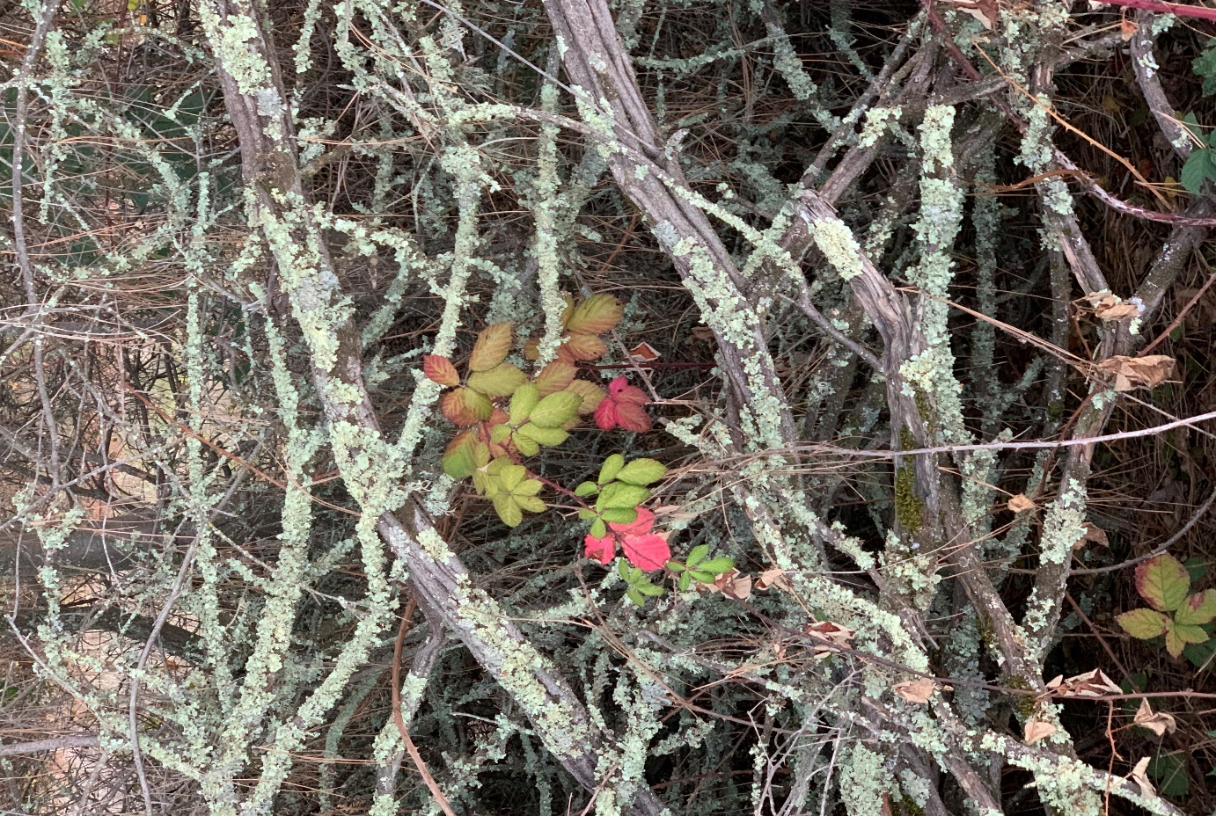

Photo credit Janet Fuller August 10, 2024

# CH 530 Chaplaincy: Models and Methods

**Hartford International University for Religion and Peace**

**Fall 2024**

**Wednesday evenings 7:00-8:50**

**DRAFT SYLLABUS (**as of 8.12.2024)

**Instructor:**

Rev. Janet Fuller, DMin

Co-Director, Master of Arts in Chaplaincy, Hartford International University

University Chaplain and Dean of Multifaith Engagement, Emeritx, Elon University

540-556-3809

[jfuller@hartfordinternational.edu](mailto:jfuller@hartfordinternational.edu)

**Office Hours**:

Dr. Fuller teaches from her office in Virginia. She may be “visited” via Zoom or phoneon Wednesdays and Thursdays 4-5 pm and by appointment. There are no office hours in October. If you need assistance during that time, please contact Dr Bilal Ansari bansari@hartfordinternational.edu

The first class is Wednesday at 7 pm. September 4

**Course Format:**

Hybrid asynchronous (1 hour) and synchronous online. There will be lectures to watch and respond to before the weekly class begins, and usually reflection essay that will bring together the information for the week’s work.

The Canvas website will provide the most accurate and up-to-date instructions for all aspects of the course. If you have difficulty accessing or navigating the site, call the Canvas Support Hotline: (877) 249-4494.

If you have questions about course content, contact your professor at jfuller@hartfordinternational.edu

**Course Description and Goals:**

As the gateway to the MAC curriculum, this course is a comprehensive, systematic introduction to professional spiritual caregiving; orientation to (or, in the case of advanced students, opportunity for reflection on) the role of the chaplain and methods suitable to the contexts in which chaplains characteristically serve (including schools, colleges, universities, prisons, health care facilities, fire and police departments, seaports, airports, the military, and mass casualty situations); and facilitates attainment of the “Common Qualifications and Competencies” and the “Standards of Practice” advocated by the Association of Professional Chaplains.

Completion of this course will enable the student to:

* Demonstrate awareness of and progress toward attaining the “Common Qualifications and Competencies for Professional Chaplains” expected of board-certified chaplains (and valuable to all chaplains).
* Demonstrate knowledge of the “Standards of Practice for Professional Chaplains” as stated by the Association of Professional Chaplains.
* Recount and apply techniques and practical information for service in spiritually and culturally diverse contexts.
* Demonstrate improved religious and interreligious literacy.
* Articulate a method of self-care for chaplains.
* Draw upon a range of sources in articulating a personal theology of spiritual care and theory of pastoral care.

**Required Textbooks [students are expected to purchase these]**

Cadge, Wendy and Shelly Rambo, eds. *Chaplaincy and Spiritual Care in the Twenty-first*  *Century: An Introduction.* The University of North Carolina Press, 2022. ISBN: 9781469667607.

Roberts, Stephen B. ed. *Professional Spiritual & Pastoral Care: A Practical Clergy and Chaplain’s Handbook.* Skylight Paths, 2012. ISBN: 1594733120.

Mabry, John R., ed. *Spiritual Guidance Across Religions: A Sourcebook for Spiritual Directors and Other Professionals Providing Counsel to People of Differing Faith Traditions*. SkyLight Paths, 2014. ISBN: 1594735468.

Browning, Jim, & Spivey, Jim, Eds. *The Heart of a Chaplain: Exploring Essentials for Ministry. BH Carroll, 2022. ISBN: 9798985832303.*

Pollack, Stanley, and Mary Fusoni. *Moving beyond icebreakers: An innovative approach to group facilitation, learning, and action*. Boston: Center for Teen Empowerment, 2005.

**Also Required: choose at least one of the following (or an approved alternative approved)**

* Ali, M. A., et al., eds. *Mantle of Mercy: Islamic Chaplaincy in North America.* Templeton Press, 2022. ISBN 978-1-59947-593-6
* Chander, Vineet and Lucinda Mosher, eds., *Hindu Approaches to Spiritual Care: Chaplaincy in*  *Theory and Practice.* Jessica Kingsley, 2020. ISBN 978-1785926051
* Friedman, Dayle E. ed., *Jewish Pastoral Care: A Practical Handbook from Traditional and*

*Contemporary Sources,* second ed. Jewish Lights, 2015. ISBN 978-1580234276

* Giles, Cheryl A. and Willa B. Miller, eds. *The Arts of Contemplative Care: Pioneering Voices in Buddhist Chaplaincy and Pastoral Work.* Wisdom Publications, 2012. ISBN 9780861716647

Other required items are provided on this course’s Canvas site.

## COURSE STRUCTURE

Topics and materials are organized in modules (units). As will be apparent when you visit the “Modules” portion of our course-site, each module has a theme; most also shine a spotlight on a particular mode of chaplaincy; and, to help us improve our interreligious literacy, most modules give special attention a particular religion. Each module’s content includes a checklist, an opening scripture-passage or prayer for reflection, an introductory lecture, reading assignments, and interactive assignments (including an opportunity to post a closing summary reflection of the module as a whole).

## Assessment

**Reflections** *50% of final grade*

This category features end-of-module posting and commenting.

**Reading Class participation** *30% of final grade*

This category features evaluation of in-class interaction with lectures, materials, reading, interaction with and learning from other students, and the concluding conversation.

**Miscellaneous graded items**: *10% of the final grade*

Writing and research assignments, and other freestanding activities**.**

**Final Summary Essay:** *10% of the final grade*

## Hartford International University Grading Scale

A (95‐100) Demonstrates excellent mastery of the subject matter, a superior ability to articulate this, and provides helpful connections to daily life or contemporary issues. Exceeds expectations of the course.

|  |  |
| --- | --- |
| A‐ (90‐94) | Demonstrates mastery of the subject matter, ability to articulate this well, and makes connections to daily life or contemporary issues. Exceeds expectations of the course. |
| B+ (87‐89) | Demonstrates a very good understanding of the subject matter, able to articulate lessons learned in the assignment well. Meets course expectations. |
| B (83‐86) | Demonstrates an understanding of the subject matter and the ability to articulate lessons learned. Meets expectations of the course. |
| B‐ (80‐82) | Demonstrates an understanding of the material at hand, has some difficulty articulating this, and basic connection of the material to daily life or contemporary issues/life. Meets basic expectations for the course. |
| C+ (77‐79) | Demonstrates a basic comprehension of the subject matter, weak articulation and connections. Does not meet expectations for the course. |
| C (70‐76) | Demonstrates a minimal comprehension of the subject matter and has difficulty making connections. Does not meet expectations of the course. |

F (below 70) Has not met the basic requirements of the course.

## HIU Values of Collaborative Teaching and Learning

Showing mutual appreciation and respect for others—modeling the privilege to learn from and partner with each other.

Engaging in cross-disciplinary content and teaching.

Paying attention to the whole personhood or another—history, race, religion, knowledge, gender, and rank.

Demonstrating how to disagree respectfully and well.

Embodying mutuality—learning to construct ideas and skills and experiences together.

## Plagiarism and Academic Integrity

Academic honesty and integrity are expected of all students. Plagiarism exists when: a) the work submitted was done, in whole or in part, by anyone other than the one submitting the work, b) parts of the work, whether direct quotations, ideas, or data, are taken from another source without acknowledgement, c) the whole work is copied from another source [especially a web based source], or d) significant portions of one’s own previous work used in another course.

## Inclusive Language

Hartford International University is committed to a policy of inclusion in its academic life and mission. All members of the community are expected to communicate in language that reflects the equality of genders, openness to diverse cultural and theological perspectives, and sensitivity to one another’s images of God.

## Accommodations

The Americans with Disabilities Act ensures equal access to qualified individuals with disabilities, and prevents discrimination on the basis of a disability. It is Hartford International University policy to provide reasonable accommodations on a case‐by‐case basis, which may mean working with outside social and governmental agencies to provide the necessary range of services for student success. Students with disabilities who wish to receive accommodations must contact the Student Services Coordinator. Students with disabilities are eligible for disability support services when they are enrolled in courses and they have disclosed their disability and requested related accommodations during enrollment and/or before the start of each semester. All students seeking accommodation must fill out the Request for Disability Accommodations form.

**Artificial Intelligence**

If you use any form of AI, doing research, translating, formatting, composing, data mining, or in any other way, you are required to cite it. Failure to do so will result in a ‘0’ for the assignment. If you use AI once, you may not use it again in the term.

## Official Handbooks

For all other questions you might have regarding policies or procedures, please see HIU’s student handbook and statement of academic policies—both available online.

## Communication and Technology

Students are expected to use their Hartford International University email for communication regarding the course. All students will need to log into the course site several times per week in order to take part in discussions and to access readings, videos, mini‐lectures and other course materials. Students must also create a free account with VoiceThread and have access via the

VoiceThread app, in Canvas, or in a separate browser window. Within Canvas, the *Announcements* feature will be used to convey information “for the good of the order.”

**About CANVAS:**

This course’s Canvas website is your primary roadmap for this course.

* Be sure to explore the site thoroughly before you begin.
* If you have difficulty navigating or operating any aspect of the site, do take advantage of the “Help” button (indicated by a question mark). The “live chat” feature works very well; you can expect prompt and clear responses to your questions. You may also phone the Canvas Support Hotline: (877) 249-4494.
* If you have questions about course content (or you tried Canvas Help but are still mystified), please do email or text-message your professor right away. If the situation is better addressed voice-to-voice, request a specific time for a phone or Zoom conversation. (Making an appointment ensures that your professor is ready to talk with you seated at her desk rather than walking her dogs or cooking a meal.

## Attendance

This is a graduate class. All students are expected to be “in class” and to participate. We will expect cameras to be on through the duration of the class. Lack of engagement with the Canvas website for seven days in a row constitutes “absence” from the course and can lead to failure. Students who believe they have a legitimate reason for such disengagement must discuss this with the professor—preferably in advance. Failure to submit an assignment or perform a required activity on time is tantamount to absence from class. If you fall behind, skip ahead to the next module so that you can stay current with your classmates in discussions. Later on, you can return to an earlier module to fill in what you missed. Late submissions are permitted, but for fewer points.

## Email Policy

The instructor will use the university’s official student email addresses for all course communications. Please check your *hartfordinternational.edu* email account regularly.

## Additional Recommended Resources

Anderson, Robert G. and Mary A. Fukuyama. *Ministry in the Spiritual and Cultural Diversity of Healthcare: Increasing the Competency of Chaplains*. Haworth Pastoral Press, 2004.

Bevans, Stephen B. *Models of Contextual Theology*, revised and expanded edition. Orbis, 2002.

Cadge, Wendy. *Spiritual Care: The Everyday Work of Chaplains*. Oxford University Press, 2023.

Cadge, Wendy. *Paging God: Religion in the Halls of Medicine*. University of Chicago, 2013.

Cooper-White, Pamela. *Shared Wisdom: Use of the Self in Pastoral Care and Counseling*, Augsburg Fortress Press, 2004.

Cutter, William. ed. *Healing and the Jewish Imagination: Spiritual and Practical Perspectives on*

*Judaism and Health*, Jewish Lights Publishing, 2007

Doehring, Carrie. *The Practice of Pastoral Care, Revised and Expanded Edition: A Postmodern Approach.* Westminster John Knox Press, 2015.

Dykstra, Robert C. *Images of Pastoral Care: Classic Readings.* Chalice Press, 2005.

Fitchett, George. *Assessing Spiritual Needs: A Guide for Caregivers.* Academic Renewal, 2002.

Forster-Smith, Lucy A., ed. *College & University Chaplaincy in the 21st Century: A Multifaith Look at the Practice of Ministry on Campuses across America*. SkyLight Paths, 2013.

Friedman, Dayle A. *Jewish Visions for Aging: A Professional Guide for Fostering Wholeness*. Jewish Lights Publishing, 2008.

Friedman, Dayle E. ed., *Jewish Pastoral Care: A Practical Handbook from Traditional and Contemporary Sources,* second ed. Jewish Lights, 2015.

Fuller, Janet. *Blessings for your Students: Prayers for Interfaith Communities in Higher Education.* Church Publishing, 2024. ISBN: 9781640656673

Giles, Cheryl A. and Willa B. Miller, eds. *The Arts of Contemplative Care: Pioneering Voices in Buddhist Chaplaincy and Pastoral Work.* Wisdom Publications, 2012.

Grefe, Dagmar, *Encounters for Change: Interreligious Cooperation in the Care of Individuals and Communities*. Wipf & Stock, 2011.

Gunderson, Gary. *Deeply Woven Roots: Improving the Quality of Life in Your Community.* Fortress Press, 1997.

Hoover, Nadine C. *Creating cultures of peace: A movement of love and conscience*. New York: Conscience Studio, 2018.

Jacobs, Martha R. *Clergy Guide to End-of-Life Issues*. Pilgrim Press, 2010.

Gunther, Margaret. *Holy Listening: The Art of Spiritual Direction.* Cowley Publications, 1992.

Lee, Jonathan. *Memento Mori: Funerals for the Unaffiliated*. Lap Lambert, 2014.

Matlins, Stuart M., ed. *The Perfect Stranger’s Guide to Funerals and Grieving Practices: A Guide to Etiquette in Other People’s Religious Ceremonies*. Skylight Paths, 2000.

Moore, S. K. *Military Chaplains as Agents of Peace: Religious Leader Engagement in Conflict and Post-Conflict Environments.* Lexington Books, 2012.

Patton, John H. *From Ministry to Theology: Pastoral Action and Reflection*. Wipf & Stock, 2009.

Roberts, Stephen. B. and Willard Ashley. *Disaster Spiritual Care: Practical Clergy Responses to Community, Regional and National Tragedy.* SkyLight Paths, 2008.

Rundle, Anne Knights, et al., eds. *Honoring Patient Preferences: A Guide to Complying With Multicultural Patient Requirements*. Jossey-Bass, 1999.

Schaper, Donna. *Approaching the End of Life: A Practical and Spiritual Guide*. Rowman & Littlefield Publishers, 2015.

Schipani, Daniel S., editor. *Multifaith Views in Spiritual Care.* Pandora Press, 2013.

Snodgrass, Jill L., ed. *Navigating Religious Difference in Spiritual Care and Counseling.* Claremont Press, 2019.

Tuell, Ra’ufa Sherry. *Islamic Approaches to Patient Care: Muslim Beliefs and Healthcare Practices for Caregivers*. Amana Publications. 2010.

Vogl, Charles H. *The Art of Community: Seven principles for belonging*. Oakland, CA: Berrett-Koehler Publishers, a BK Currents Book, 2016.

Waggoner, Ed. “Taking Religion Seriously in the U.S. Military: The Chaplaincy as a National Strategic Asset” in *Journal of the American Academy of Religion,* 82/3, pp. 702–35.

Wimberly, Edward P. *Recalling Our Own Stories: Spiritual Renewal for Religious Caregivers*. Jossey-Bass, 1997.